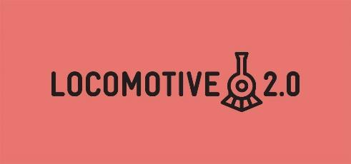
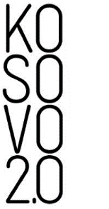

Grant proposal form for the Lokomotiva Program

Application deadline:
Submit the application to this email:

The application should be filled out on a computer.
The project can be written in Albanian, English and/or Serbian language(s).
Part I: General information
Name of the initiative:
Duration of the initiative:
Location where the initiative will be implemented:
Responsible person for the initiative: (name, surname, email address, telephone number)
Initiative’s team members:
(name, surname, email address, telephone numbers)
Theme of the proposal:  (choose one) | - gender  - race  - ethnicity  - religion
Total required budget:
Submission date:

Part II: Information about the project proposal
- What problem do you want to address through your initiative? Max. ½ page

- What are the three main objectives of your initiative?

- How do you plan to address the problem? Describe in detail the activities that you will implement, including the steps you will undertake, responsible persons, location where activities will take place, people you will collaborate with, participants, and other details that you consider relevant. Max. 3 pages

- Project results (List the results that you aim to achieve through your initiative.) Max. ½ page

- If your project gets selected, Kosovo 2.0 will provide a mentor to help you implement the project. Please, describe in 2-3 sentences the profile of the mentor that you would like to help you with the project implementation: What kind of experience should the mentor have or which project aspects do you feel need mentoring?

